

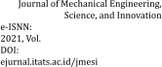TECHNO-ECONOMIC ANALYSIS OF THE PRODUCTION OF MAGNESIUM OXIDE NANOPARTICLES USING SOL-GEL METHOD

**Anisa Noorlela1, Asep Bayu Dani Nandiyanto2, Risti Ragadhita3, Meli Fiandini4, Tedi Kurniawan5**

1,2,3,4Departement of Chemistry Education, Universitas Pendidikan Indonesia, Indonesia

5Community College of Qatar, Qatar

***Corresponding author:***

*Anisa Noorlela*

*Universitas Pendidikan Indonesia, Indonesia Email:* [*anisanoorlela@upi.edu*](mailto:anisanoorlela@upi.edu)

***Abstract***

*The aim of this research is to analyze the feasibility of a project to produce magnesium oxide (MgO) nanoparticles using the sol-gel method and evaluate it from a technical and economic point of view. Evaluation from a technical perspective is carried out by calculating stoichiometry and evaluating the factory's initial plan, while evaluation from an economic perspective is determined by several parameters that will determine the profit of the project to be built (Gross Profit Margin, Internal Rate Return, Break Even Point, Payback Period, and Cumulative Net Present Values). Several economic evaluation parameters are analyzed to provide information about the production potential of magnesium oxide nanoparticles, such as determining the level of project profitability (Gross Profit Margin), predicting the time required from investment to amortization of initial capital costs (Payback Period), predicting project production requirements according to the production function in years (Cumulative Net Present Value), etc. The results showed that the production of MgO nanoparticles is very promising. An engineering analysis for producing 1,875 kg of MgO nanoparticles per day revealed that the total cost of the equipment purchased was 45,373 USD. The Payback Period analysis shows that the investment pays off after more than three years. This project is able to compete with PBP capital market standards because the investment will return by itself in a short time. To ensure the feasibility of the project, it is necessary to evaluate the project from ideal production conditions to the worst conditions, including labor, salaries, sales, raw materials, utilities, and external conditions such as taxes.*

***Keywords:*** *MgO nanoparticles, sol-gel method, economic evaluation, feasibility study*

Creative Commons CC BY: This article is distributed under the terms of the Creative Commons Attribution 4.0 License (<http://www.creativecommons.org/licenses/by/4.0/)>which permits any



use, reproduction and distribution of the work without further permission provided the original work is attributed as specified on the Open Access pages.

# INTRODUCTION

Magnesium oxide (MgO) is one of the functional metal oxides and has been widely used in various fields. MgO can be used for ceramic materials because it has a high melting point that makes it fire resistant, has a strong surface, is water resistant, soundproof, resistant to attack by mold, mildew and decay [1]. MgO has excellent optical, electrical, thermodynamic, electronic and mechanical properties. In the industrial world, MgO is usually used to make materials that function as heat-resistant walls in furnaces, electrical insulators, food packaging, cosmetics, pharmaceutical manufacturing [2], catalysts [3], bactericidal properties [4], photocatalytic [5], adsorbents [6], optical properties [7], electrochemical biosensors [8], refractory materials, paints, and superconductors [9].

Magnesium oxide nanoparticles are metal oxide nanoparticles which are highly ionic in nature with a very high surface area and an unusual crystal morphology [9]. Magnesium oxide nanoparticles have been widely used because they have unique properties, namely a wide bandgap, the ability to maintain thermodynamic stability, a low dielectric constant, and a low index of refraction [10]. Several methods can be used in the synthesis of magnesium oxide nanoparticles, including combustion [11], synthesis of plant extracts [12], sonochemical synthesis [13], solid-state synthesis [14], and sol-gel synthesis [15]. In this research, synthesis of magnesium oxide by sol-gel method was used. The sol-gel method is a widely used method for synthesizing magnesium oxide nanoparticles because the process is simple, the product yield is quite high, and the reaction temperature is low. In addition, the sol-gel method is relatively inexpensive to obtain magnesium oxide nanoparticles with a narrow size distribution and larger surface area which is very important to overcome the problem of low reactivity and catalytic ability [16]. Figure 1. shows a flow chart for preparing magnesium oxide nanoparticles using the sol-gel method.

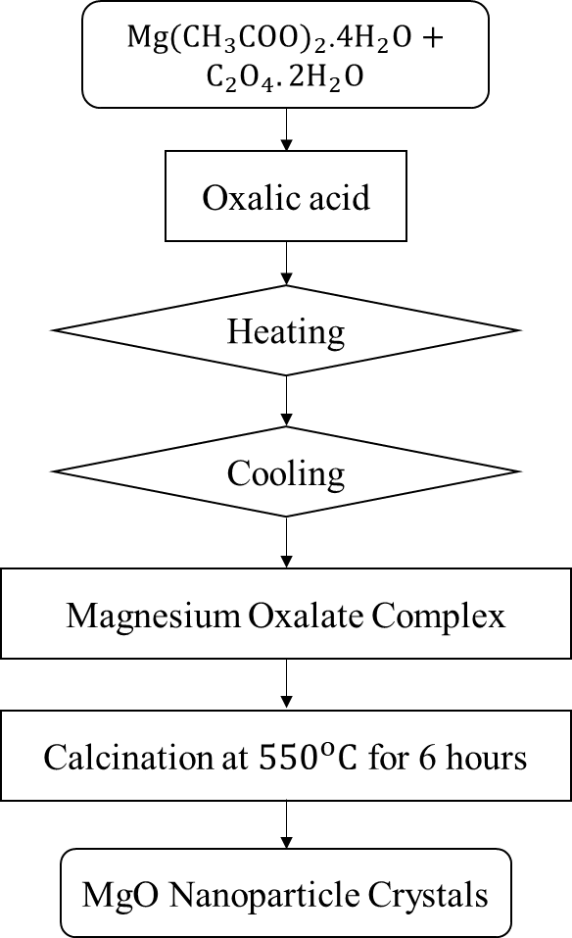

**Figure 1.** Schematic diagram of the MgO nanoparticles production process using the sol- gel method.

Until now, many studies have explained how magnesium oxide nanoparticles are synthesized, but the economic evaluation of the synthesis of magnesium oxide nanoparticles by the sol-gel method on an industrial scale has not been widely studied. Therefore, the aim of this research is to analyze the economic evaluation of a project that produces magnesium oxide nanoparticles using the sol-gel method on an industrial scale. This evaluation can be done from two sides, namely the technical and economic sides. From a technical point of view, it can be determined by calculating stoichiometry, mass balance, and evaluating the initial plant design. Meanwhile, evaluation from an economic point of view can be determined by several parameters including the value of Gross Profit Margin, Internal Rate of Return, Break Even Point, Payback Period, and Cumulative Net Present Value which will determine the benefits of the project to be established under various conditions [17].

# METHODS

In this study, we chose a research procedure for the synthesis of MgO nanoparticles from an experiment conducted by Sutapa et al. (2018) used magnesium acetate tetrahydrate (Mg(CH3COO)2.4H2O) and oxalic acid dehydrate (C2O4.2H2O) as raw materials [18]. Economic evaluation is carried out by means of price analysis of equipment, utilities, and raw materials used for the production of magnesium oxide nanoparticles on the Alibaba online shopping website. The data is then calculated using Microsoft Excel with several parameters such as Gross Profit Margin, Internal Rate Return, Break Even Point, Payback Period, and Cumulative Net Present Value of various variable costs. Calculations are based on literature [17]. To get the results of this study, calculations were carried out using several formulas, such as:

* Gross Profit Margin (GPM) is the first analysis that can determine the level of profitability of a project. This analysis can be evaluated by reducing sales costs with raw material costs [17].

*GPM* = 𝛴𝑡𝑟 (S . 𝜂 − RM) PC . Q . t (1)

tr=1

S is total sales, RM is total raw material, PC is production capacity, Q is raw material capacity included and used in the process (kg/hour), and t is production time.

* Internal Rate Return is a representation that shows the average interest income per year for all expenses and income in the same amount. If the Internal Rate of Return is higher than the prevailing real interest rate (current bank lending rates), then the factory is considered profitable, but conversely if the Internal Rate of Return is lower than the prevailing real interest rate, then the factory is considered to be in deficit [17].

*NPV* = 𝛴𝑡𝑟 𝐶𝑜 - Co (2)

𝑡𝑟=1 𝑡𝑟

(1+𝑖)

Co is the total investment cost, Ct is the net cash flow during the period, tr is the project duration per year, and i is the discount rate that can be obtained from alternative investments.

* Break Even Point (BEP) is the minimum total product value that must be sold at a certain price to cover production costs. Break Even Point can be calculated by dividing fixed costs by profits [17].
* Payback Period (PBP) is a calculation that can be used to predict the time required for an investment to return its initial investment (initial capital). In short, the Payback Period is calculated when the Cumulative Net Present Value reaches zero [17].
* Cumulative Net Present Value (CPNV) is the total Net Present Value (NPV) from the start of the factory construction to the end of the plant's operation [17].

*NPV* = 𝛴𝑡𝑟 ( 𝑅𝑡 ) (3)

𝑡𝑟=1

(1+𝑖)𝑡𝑟

Rt is the net cash inflow less cash outflow during a period tr, i is the discount rate that can be obtained from alternative investments, and tr is the duration of the project per year.

# RESULTS AND DISCUSSIONS

**Engineering Perspective**

Several assumptions were used in this study based on the representation in Figure 2 which shows the production process of magnesium oxide nanoparticles and the flow diagram for the manufacture of magnesium oxide nanoparticles shown in Table 1. These assumptions are shown by stoichiometric calculations which will increase the yield of magnesium oxide production if the project is scaled up. In this study, the production output after increasing the project resulted in approximately 1,875 kg of magnesium oxide nanoparticles in one production cycle (per day). Assumptions that need to be improved include: (1) All raw materials are increased up to 2,000 times compared to lab scale in the literature. (2) The materials used are of high purity. (3) Magnesium acetate tetrahydrate and oxalic acid dehydrate react to produce magnesium oxide with a purity of 98%. (4) There is a loss of 2% during the process of decantation, drying and product collection.

In industrial projects, assumptions are needed to ensure economic evaluation analysis and predict various possibilities that will occur during the project. The assumptions are: (1) All analyzes use USD. 1 USD = 15,628 rupiah [19]; (2) Based on commercially available prices, the prices for magnesium acetate tetrahydrate and oxalic acid dehydrate are 2.025 USD/kg and 0.6 USD/kg. All materials are evaluated based on stoichiometric calculations; (3) Have purchased the project site (land). Thus, land costs can be added at the beginning of the factory construction year and can be recovered after the project ends (4) Total Investment Cost (TIC) can be calculated using the Lang Factor [20]; (5) Total Investment Cost is made in at least two stages. The first phase is 40% in the first year and the second phase is the remainder (during the project construction phase); (6) Depreciation is estimated by direct calculation [20]; (7) In every one cycle of magnesium oxide nanoparticle production takes 16 hours; (8) Shipping costs are charged to the customer; (9) Magnesium oxide nanoparticles are sold at 2 USD/pack (1 kg); (10) The annual project will last 300 days (the remaining days are used for cleaning and process management); (11) To facilitate supply, utility units can be broken down and converted into electricity units, for example kWh [17]. Then, electricity units can be converted into payments (fees). The unit of electricity (kWh) multiplied by the cost of electricity. The operating cost assumption is 0.071 USD/kWh; (12) The total wage/labor is assumed to be a fixed value of 62.91 USD/day; (13) Discount rate of 15% per year; (14) Income tax of 10% per year; (15) When the project was carried out for 10 years.

Economic evaluation analysis aims to test the feasibility of the project. This economic evaluation is carried out by varying the value of raw materials, utilities, sales, labor, and taxes under different conditions. For variations in raw materials, utilities, sales, and labor, they are made at 50%, 75%, 100%, 125%, 150%, 175% and 200%, while

variations in taxes are carried out at 10%, 25%, 50%, 75 %, and 100%.

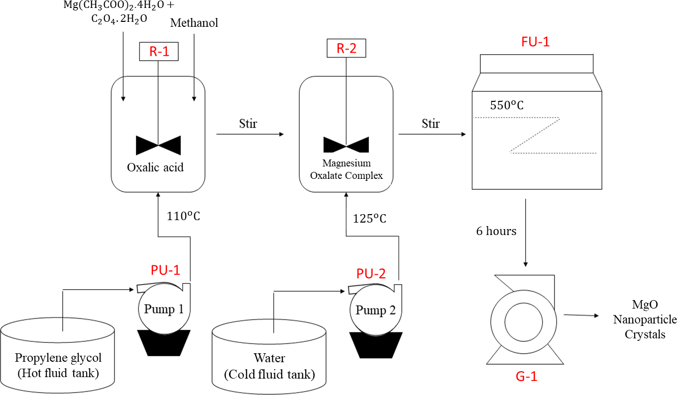

**Figure 2.** PFD on the synthesis of MgO nanoparticles

**Table 1.** Table of the process flow diagram for the manufacture of MgO nanoparticles

|  |  |  |
| --- | --- | --- |
| No. | Symbol | Information |
| 1. | R-1 | Reactor-1 |
| 2. | R-2 | Reactor-2 |
| 3. | PU-1 | Pump-1 |
| 4. | PU-2 | Pump-2 |
| 5. | FU-1 | Furnace-1 |
| 6. | G-1 | Grinding-1 |

Figure 2 shows the processing conditions for producing magnesium oxide (MgO) nanoparticles using the sol-gel method. The synthesis procedure for MgO nanoparticles was taken from an experiment Sutapa et al. (2018), namely using magnesium acetate tetrahydrate (Mg(CH3COO)2.4H2O) and oxalic acid dehydrate (C2O4.2H2O) as raw materials. First of all, the raw material is dissolved with methanol in the reactor for 120 minutes and the heating process is carried out at 110oC. The constant heating process will produce a clear colored mixture. The mixture obtained was adjusted to pH 5 by adding oxalic acid to the solution and followed by a stirring process until a white gel was obtained. Then the resulting gel was transferred to the next reactor for the cooling process at room temperature and left for 12 hours so that the gelation process was complete. The gel is then filtered to separate the gel and the solution. The solid obtained was heated at 110°C for 24 hours to remove water and acetate trapped in the solid formed, then cooled to room temperature. Furthermore, the dry product was refined using a special mechanical refiner to produce a magnesium oxalate complex which functions as a precursor for the manufacture of MgO nanoparticles. The complex formed is then calcined at certain temperatures: 400; 450; 500; 550℃, but in the experiments conducted Sutapa et al. (2018), the calcination temperature can be carried out at 550℃ with a pressure of 1

atm for 6 hours [18]. This process will produce MgO nanoparticle crystals. Each production cycle produces 1,875 kg of magnesium oxide nanoparticles. In one month, the project can produce 46,875 kg and in one year produce 562,500 kg of magnesium oxide nanoparticles.

From an engineering perspective, the total cost incurred by a project to purchase magnesium oxide raw material for one year is 78,750 USD, while the total sales obtained in one year is 337,500,000 USD. The profit earned for one year is 337,421,250 USD. The costs incurred to purchase the equipment amounted to 45,373 USD. Total Investment Cost (TIC) must be less than 192,381.52 USD. This project will be implemented for 10 years and will produce magnesium oxide nanoparticles with a Cumulative Net Present Value/Total Investment Cost reaching 4977.176% in the tenth year and the Payback Period has been successfully achieved in the third year.

# Economic Evaluation

1. **Ideal Conditions**

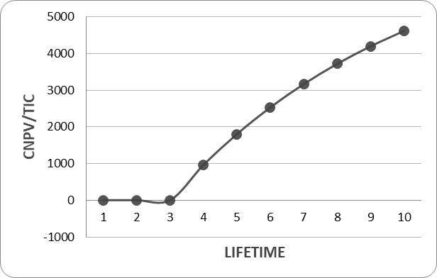The graph of the relationship between Cumulative Net Present Value/Total Investment Cost to time can be seen in Figure 3. In the graph, the y-axis shows Cumulative Net Present Value/Total Investment Cost, while the x-axis shows life time (year). From the graph it can be seen that the cumulative value of the Cumulative Net Present Value/Total Investment Cost is negative (%), which is less than 0 from the first year to the third year, which indicates a decrease in income in that year due to the initial capital outlay to produce magnesium nanoparticles oxide. In the third year, the graph shows an increase in income, where this condition is the Payback Period (PBP). The profits earned can be used to cover the initial capital that has been issued and profits will continue to increase thereafter until the tenth year. The negative value of the Cumulative Net Present Value/Total Investment Cost from the first year to the second year can be seen in Table 2. Then the value of the Cumulative Net Present Value/Total Investment Cost starts to return to positive in the third year. Therefore, the production of magnesium oxide nanoparticles can be regarded as a profitable business because the production of magnesium oxide nanoparticles requires a short time to cover investment costs.

**Figure 3.** Ideal conditions *Cumulative Net Present Value*/*Total Investment Cost* for

*life time (year)*

**Table 2.** Annual cumulative net present value under ideal conditions.

|  |  |
| --- | --- |
| **CNPV/TIC** | **Year** |
| 0 | 0 |
| -0,409351928 | 1 |
| -0,845204551 | 2 |
| 963,8091576966 | 3 |
| 1802,6390379121 | 4 |
| 2532,0563250560 | 5 |
| 3166,3322269202 | 6 |
| 3717,8764894109 | 7 |
| 4197,4801959245 | 8 |
| 4977,1762027330 | 9 |
| 4977,1762027330 | 10 |

# Influence of External Conditions

Several factors of external conditions can affect the success of a project. One factor is the taxes levied by the government to finance various public expenditures. The graph of Cumulative Net Present Value with various tax variations can be seen in Figure 4. In the graph, the y-axis shows Cumulative Net Present Value/Total Investment Cost (%) while the x-axis shows life time (years). Figure 4 shows that the conditions from the beginning of the year to two years show the same results, this is because the Cumulative Net Present Value is under variations in taxes and there is project development. In addition, in that year there was no income and deductions were made according to the graph of ideal conditions. Profits continue to increase after reaching the Payback Period (PBP) point until the tenth year. The cumulative net present value/total investment cost in the tenth year for each variation of 10%, 25%, 50%, 75% and 100% is 9.57; 23.94; 47.87; 71.81; and 95.751%. So, the

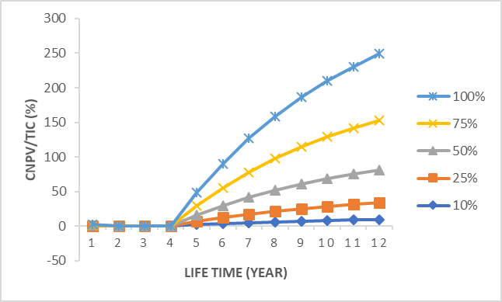maximum tax to get the Break Even Point (the point where both gains and losses in the project) is 75%. Changes in taxes to more than 75% make the project fail.

**Figure 4.** Cumulative Net Present Value curve for tax variations

# Sales Changes

The graph of Cumulative Net Present Value with different sales variations and Payback Period results can be seen in Figure 5. In the graph, the y-axis shows Cumulative Net Present Value/Total Investment Cost while the x-axis shows life time (year). Project provisions for Cumulative Net Present Value from the first year to the second year are the same in different variations. This happened because of the development project. The effect of sales on the Cumulative Net Present Value can be determined after the implementation of the project for 2 years. The higher the sales value, the higher the profit from the realized project. However, if conditions occur that cause a decrease in product sales, the project revenue will decrease from ideal conditions.

Based on Payback Period analysis, return on investment can be achieved with sales fluctuations of 25%, 50%, 75%, 100%, 125%, 150%, 175% and 200% in the third year. Profits will continue to increase after reaching the Payback Period (PBP) until the third year when the cumulative profit margin for the year increases as sales increase from ideal conditions. Cumulative Net Present Value/Total Investment Cost in the tenth year for each variation of 25%, 50%, 75%, 100%, 125%, 150%, 175%,

and 200% is 1244.29; 2488.58; 3732.88; 4977.17; 6211.47; 7465.76; 8710.06; and

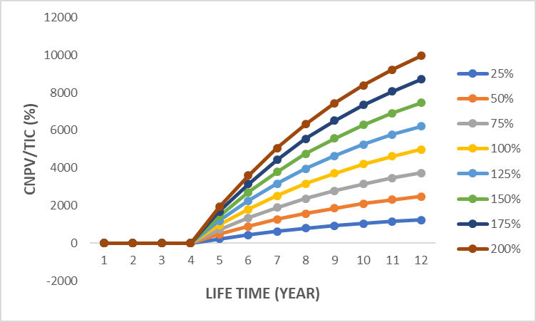9954.35%. Therefore, the minimum revenue to reach the Break Even Point (the point at which the project gains or loses) is 50%. Sales of magnesium oxide nanoparticles will be more profitable when turnover increases by more than 50% because the graph shows a positive Cumulative Net Present Value/Total Investment Cost, which means the project is feasible to run [21].

**Figure 5.** Cumulative Net Present Value curve for variations in sales

# Changes in variable costs (raw materials, labor wages, utilities)

The success of a project can be influenced by several internal factors, including the condition of raw materials, labor and utilities. Analysis can be done by evaluating the project with Gross Profit Margin (GPM) analysis in various conditions of raw materials and sales as shown in Figure 6. This analysis is evaluated by subtracting the cost of goods sold from the cost of raw materials [22]. The results of the analysis show a positive correlation between sales and GPM, while raw materials show a negative (opposite) correlation. In this case, the increase in sales will directly impact the success of the project (profitability), while the price of raw materials will have an impact on the sustainability of the project. Based on the analysis, the two raw materials used, namely magnesium acetate and oxalic acid, have an effect similar to

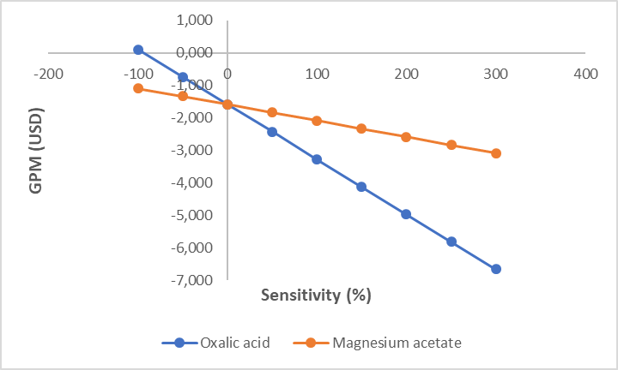GPM. If seen from the graph in Figure 6, the raw material parameter that has the most influence is oxalic acid because it shows a steeper curve compared to magnesium acetate.

**Figure 6.** Effect of changes in raw material cost to Gross Profit Margin (GPM).

Apart from raw materials and sales, project financial conditions can also be affected by the amount of labor and utilities which can be seen in Figure 7 and Figure

8. The figures shown in the graph explain the estimated Profitability Index (PI) as a function of sales, raw materials, labor , and utilities. Sales factors are positively correlated with GPM, while raw materials, labor, and utilities are negatively correlated with GPM.

Based on the PI profit-to-sales chart shown in Figure 7, sales have an exponential curve effect on the PI value. The PI value changed from 0.926 to 0.930. These results are consistent with the fact that declining sales have a direct impact on revenue, especially when the sensitivity fluctuates between -50 and 0%. But the increase in sales does not affect the results because the increase in sales is associated with changes in variable costs. Therefore, sales must be carried out optimally in order to obtain optimal profits as well. The next effect is raw materials that produce a linear curve, meaning that an increase in raw materials directly affects the success (profitability) of the project. For labor, this cost increase has a smaller impact compared to sales and raw materials, i.e. the PI varies between -50 and 150%. Meanwhile utility shows the smallest impact, namely PI only varies between 0 to 50%.

Based on the profit-to-investment PI chart shown in Figure 8, a relatively straight linear curve for sales parameters is obtained. This indicates that sales growth directly affects the success (profitability) of the project. For raw material and utility parameters, a horizontal curve is obtained indicating that sales growth does not affect the success (profitability) of the project. The last is the labor parameter which shows a curve with a PI varying between -50 to 100%.

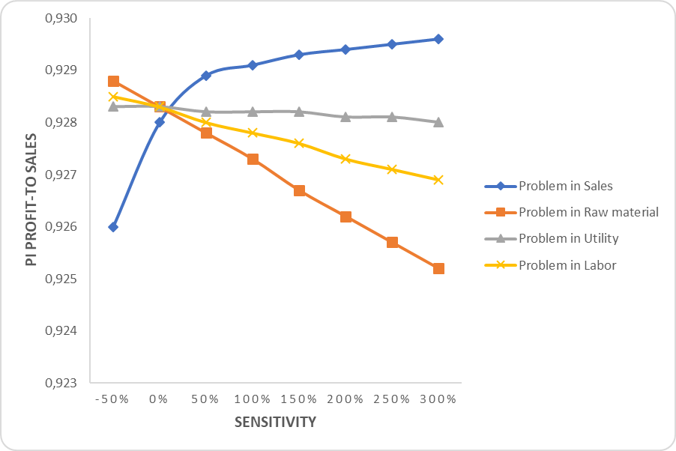

**Figure 7.** Analysis of Profitability Index (PI) profit to sales as a function of sales, raw

material, utility, and labor

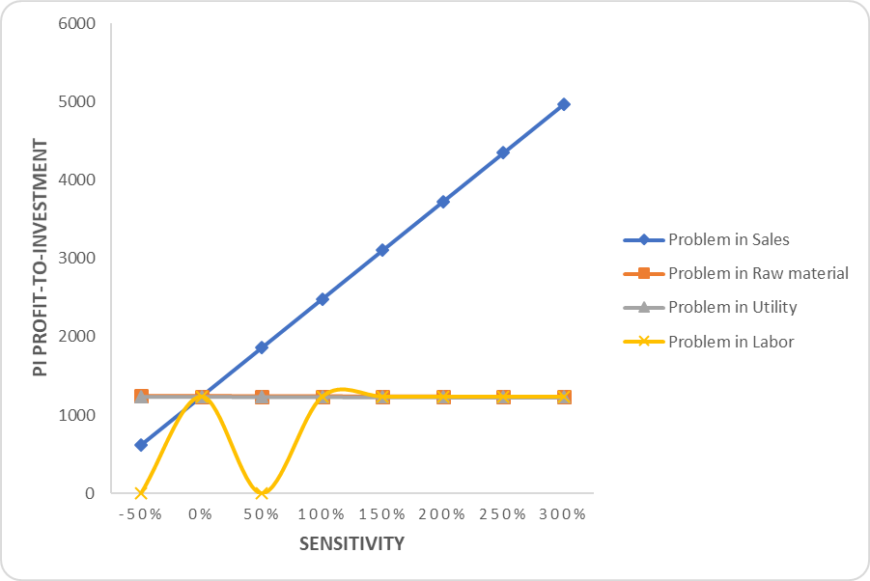

**Figure 8.** Analysis of Profitability Index (PI) profit to investment as a function of sales, raw material, utility, and labor.

Based on the analysis above, the project for the production of magnesium oxide nanoparticles is feasible to run under ideal conditions. This project will only be profitable under certain economic conditions and will incur losses if the project is implemented under certain economic conditions. Below is an explanation of the provisions of these economic conditions: (1) Taxes affect project profits. Taxes must be clearly estimated, because the maximum tax to sustain the project must be less than 75%. (2) Conversion must be maintained in the range of more than 90%. If conversion is less than 90%, the project is considered a failure. (3) Changes in raw material prices with fluctuations of 50, 75, 100, 125, 150, 175 and 200% will affect annual profits. Although the project is still operational, it will generate little profit if the commodity price exceeds 100%. (4) Labor

costs with fluctuations of 50, 75, 100, 125, 150, 175 and 200% do not affect the profit generated. This is because labor costs account for about 0.02% of profits. (5) User fees (electricity costs) do not affect the profits generated. This is because labor costs account for about 0.02% of profits. (6) Variable cost variation analysis was carried out by Nandiyanto, A., [23] and Nandatamadini, F., et al [24]. They stated that the results of the analysis of variable costs with various variations played an important role in profits and reduced variable costs could affect the final high value of CNPV. With increasing variable cost, the project will suffer losses. But when using a lower variable cost value, the project will be more effective in generating more profits. In the results of this study the most influential variable cost is the cost of raw materials and the level of sales. This can be seen from the changes in each curve on the GPM chart. In addition to the economic prospects, this project must be analyzed for its attractiveness to investors, but this project is a less attractive perspective for industrial investors. This perspective refers to the standard Indonesian capital market [23]. In addition, this study does not demonstrate a newly designed process. However, the new idea in this research can provide knowledge and information about the feasibility of making MgO nanoparticles.

# CONCLUSIONS

Based on the techno-economic analysis that has been carried out, the project for the production of magnesium oxide nanoparticles using the sol-gel method from an engineering point of view shows that increasing the scale of the project can be carried out using currently available tools and has a relatively inexpensive price. Payback Period analysis shows that the investment is profitable after more than three years. This is because the use of raw materials in the process of synthesizing magnesium oxide nanoparticles using the sol-gel method is cheap and requires a short time to produce magnesium oxide. From the economic evaluation analysis it can be concluded that this project is feasible to run.

# REFERENCES

1. Agrawal, R. M., Charpe, S. D., Raghuwanshi, F. C., & Lamdhade, G. T, Synthesis and characterization of magnesium oxide nanoparticles with 1: 1 molar ratio via liquid- phase method. *International Journal of Application or Innovation in Engineering & Management*, *4*(2), 141-145 (2015).
2. Alvionita, N., & Astuti, A, Sintesis Nanopartikel Magnesium Oksida (MgO) dengan Metode Presipitasi. *Jurnal Fisika Unand*, 6(1), 89-92 (2017).
3. Yuan, G., Zheng, J., Lin, C., Chang, X., & Jiang, H, Electrosynthesis and catalytic properties of magnesium oxide nanocrystals with porous structures. *Materials Chemistry and Physics*, 130(1-2), 387-391 (2011).
4. Zhang, K., An, Y., Zhang, L., & Dong, Q, Preparation of controlled nano-MgO and investigation of its bactericidal properties. *Chemosphere*, 89(11), 1414-1418 (2012).
5. Mantilaka, M. P. G., De Silva, R. T., Ratnayake, S. P., Amaratunga, G., & de Silva, K. N, Photocatalytic activity of electrospun MgO nanofibres: Synthesis, characterization and applications. *Materials Research Bulletin*, 99, 204-210 (2018).
6. Mahmoud, H. R., Ibrahim, S. M., & El-Molla, S. A, Textile dye removal from aqueous solutions using cheap MgO nanomaterials: adsorption kinetics, isotherm studies and thermodynamics. *Advanced Powder Technology*, 27(1), 223-231 (2016).
7. Stankic, S., Müller, M., Diwald, O., Sterrer, M., Knözinger, E., & Bernardi, J, Size- dependent optical properties of MgO nanocubes. *Angewandte Chemie International Edition*, 44(31), 4917-4920 (2005).
8. Umar, A., Rahman, M. M., & Hahn, Y. B, MgO polyhedral nanocages and nanocrystals based glucose biosensor. *Electrochemistry Communications*, 11(7), 1353-1357 (2009).
9. Dobrucka, R, Synthesis of MgO nanoparticles using Artemisia abrotanum herba extract and their antioxidant and photocatalytic properties. *Iranian Journal of Science and Technology, Transactions A: Science*, 42(2), 547-555 (2018).
10. Prasanth, R., Kumar, S. D., Jayalakshmi, A., Singaravelu, G., Govindaraju, K., & Kumar,

V. G, Green synthesis of magnesium oxide nanoparticles and their antibacterial activity. (2019).

1. Balakrishnan, G., Velavan, R., Batoo, K. M., & Raslan, E. H, Microstructure, optical and photocatalytic properties of MgO nanoparticles. *Results in Physics*, 16, 103013 (2020).
2. Essien, E. R., Atasie, V. N., Okeafor, A. O., & Nwude, D. O, Biogenic synthesis of magnesium oxide nanoparticles using Manihot esculenta (Crantz) leaf extract. *International Nano Letters*, 10(1), 43-48 (2020).
3. Yunita, F. E., Natasha, N. C., Sulistiyono, E., Rhamdani, A. R., Hadinata, A., & Yustanti, E, Time and amplitude effect on nano magnesium oxide synthesis from bittern using sonochemical process. *In IOP Conference Series: Materials Science and Engineering*, 858(1), 012045 (2020).
4. Zhang, H., Hu, J., Xie, J., Wang, S., & Cao, Y, A solid-state chemical method for synthesizing MgO nanoparticles with superior adsorption properties. *RSC Advances*, 9(4), 2011-2017 (2019).
5. Taghavi Fardood, S., Ramazani, A., & Woo Joo, S, Eco-friendly synthesis of magnesium oxide nanoparticles using arabic Gum. *Journal of Applied Chemical Research*, 12(1), 8-15 (2018).
6. Mguni, L. L., Mukenga, M., Jalama, K., & Meijboom, R, Effect of calcination temperature and MgO crystallite size on MgO/TiO2 catalyst system for soybean oil transesterification. *Catalysis Communications*, 34, 52-57 (2013).
7. Nandiyanto, A. B. D, Cost analysis and economic evaluation for the fabrication of activated carbon and silica particles from rice straw waste. *Journal of Engineering Science and Technology*, *13*(6), 1523-1539 (2018).
8. Sutapa, I. W., Wahab, A. W., Taba, P., & La Nafie, N, Synthesis and structural profile analysis of the MgO nanoparticles produced through the sol-gel method followed by annealing process. *Oriental Journal of Chemistry*, 34(2), 1016 (2018).
9. Bank Indonesia, “Foreign Exchange Rates”. [Online]. Available: https:[//w](http://www.bi.go.id/id/statistik/informasi-kurs/transaksi-bi/Default.aspx)ww[.bi.go.id/id/statistik/informasi-kurs/transaksi-bi/Default.aspx,](http://www.bi.go.id/id/statistik/informasi-kurs/transaksi-bi/Default.aspx) 2022, retrieved December 26, 2022.
10. Garrett, Donald E, *Chemical engineering economics*, Springer Science & Business Media, 2012.
11. Nandatamadini, F., Karina, S., Nandiyanto, A. B. D., & Ragadhita, R, Feasibility study based on economic perspective of cobalt nanoparticle synthesis with chemical reduction method. *Cakra Kimia (Indonesian E-Journal of Applied Chemistry)*, *7*(1),

61-68 (2019).

1. Garrett, D. E, *Chemical engineering economics*. Springer Science & Business Media, (2012).
2. Winter, O, Preliminary economic evaluation of chemical processes at the research level. *Industrial & Engineering Chemistry*, *61*(4), 45-52 (1969).
3. Nandiyanto, A. B. D., T. Rahman, M. A. Fadhlulloh, A. G. Abdullah, I. Hamidah, and B. Mulyanti, Synthesis of silica particles from rice straw waste using a simple extraction method. In *IOP Conference Series: Materials Science and Engineering*, vol. 128, no. 1, p. 012040. IOP Publishing, (2016).